# Unraveling the Crucial Importance of Cybersecurity Frameworks

NIST CSF v1.1, Digital Security, Best Practices, Culture

July 31, 2023

[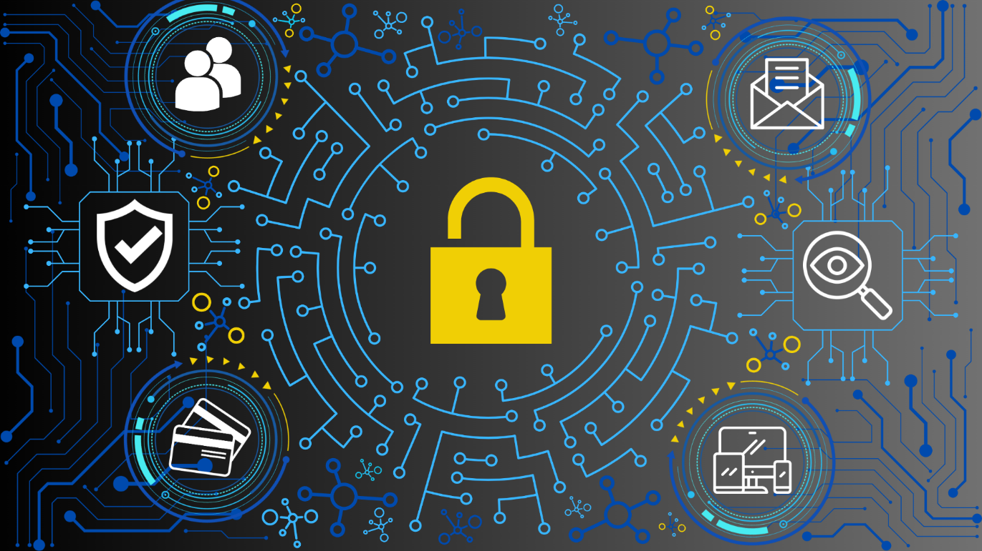](https://user-images.githubusercontent.com/131223318/259469958-5160af75-a89f-4c39-bf7e-c26f3c3de6cb.png)

In the digital age, where information reigns supreme, the significance of cybersecurity cannot be overstated. With the increasing reliance on technology, businesses, governments, and individuals find themselves more vulnerable to cyber threats than ever before. In the midst of this digital frontier, a guiding light emerges in the form of the National Institute of Standards and Technology (NIST) Cybersecurity Framework (CSF). This groundbreaking framework provides a comprehensive and adaptable approach to safeguarding against cyber threats. Join me as we explore the unique and captivating world of cybersecurity frameworks and delve into the core essence of the NIST CSF.

## A World Under Siege

As the digital revolution continues to surge forward, the frequency and sophistication of cyberattacks have grown exponentially. From ransomware assaults crippling major organizations to personal data breaches undermining the trust of millions, the need for a robust cybersecurity defense is now more critical than ever. Cyber threats respect no boundaries, and no organization, big or small, can consider itself immune. Amid this crisis, cybersecurity frameworks emerge as a beacon of hope.

## What Are Cybersecurity Frameworks?

A cybersecurity framework can be defined as a structured methodology designed to identify, assess, and manage cybersecurity risks within an organization. These frameworks serve as a blueprint to develop comprehensive security strategies, policies, and procedures tailored to specific needs. They facilitate the alignment of security measures with business objectives, ensuring a harmonious blend of protection and productivity.

## NIST CSF

At the forefront of the cybersecurity framework landscape stands the NIST Cybersecurity Framework (NIST CSF). Developed by the National Institute of Standards and Technology (NIST), this pioneering framework was created through extensive collaboration with industry professionals, government agencies, and academia. The NIST CSF is a living document, continuously evolving to meet the dynamic challenges of the cyber landscape.

## Pillars of the NIST CSF

The NIST CSF consists of five core functions, each crucial to establishing a robust cybersecurity posture:

* ***a) Identify:*** This function involves understanding and managing cybersecurity risks to systems, assets, data, and capabilities. Organizations must grasp the full extent of their vulnerabilities to devise an effective security strategy.
* ***b) Protect:*** Focusing on safeguards, the "Protect" function assists in developing and implementing measures to defend against potential cyber threats. This includes everything from access control and data encryption to training employees about safe online practices.
* ***c) Detect:*** Organizations must possess the capability to quickly identify and respond to cybersecurity incidents. The "Detect" function emphasizes continuous monitoring and anomaly detection to minimize the damage caused by cyberattacks.
* ***d) Respond:*** In the event of a cyber incident, timely and efficient response is critical. The "Respond" function outlines the necessary steps to mitigate the impact of breaches, recover lost data, and restore normal operations.
* ***e) Recover:*** The final function, "Recover," addresses the process of restoring systems and services after a cybersecurity event. This includes conducting post-incident reviews, learning from the experience, and fortifying defenses for the future.

## Tailoring the NIST CSF

One of the greatest strengths of the NIST CSF lies in its adaptability. Organizations of all sizes and industries can customize the framework to suit their specific needs and risk profiles. Whether you're a tech giant or a local business, the NIST CSF provides a roadmap to enhance your cybersecurity posture and withstand the ever-changing threat landscape.

## Cybersecurity Culture

Beyond the technical aspects, the NIST CSF emphasizes the significance of cultivating a cybersecurity-conscious culture within an organization. Employees are the first line of defense against cyber threats, and their awareness and vigilance play a pivotal role in safeguarding digital assets. Here are some strategies to help enhance this culture:

* ***Gamified Training Modules:*** Transform cybersecurity education into interactive games or simulations. This not only engages employees but also makes learning about cyber threats and best practices enjoyable. Offering rewards or recognition for achieving certain milestones can further incentivize participation.
* ***Role-Specific Training Tracks:*** Tailor cybersecurity training to different job roles within the organization. By addressing specific risks and challenges that each department faces, employees can better understand how cyber threats directly impact their responsibilities and be more motivated to stay vigilant.
* ***Hackathons for Security:*** Organize internal "hackathons" or simulated cyber attack events. This hands-on experience allows employees to see the potential vulnerabilities in the organization's systems and encourages them to think like attackers, thereby boosting their proactive mindset towards security.
* ***Phishing Simulations with Feedback:*** Conduct realistic phishing simulations, but take it a step further by providing personalized feedback to employees who fall for these simulated attacks. This feedback can help employees understand their mistakes and reinforce good cybersecurity habits.
* ***Interactive Workshops and Webinars:*** Collaborate with external experts to host interactive workshops and webinars on evolving cyber threats and defense mechanisms. These sessions can provide employees with up-to-date insights while allowing them to interact directly with experts.
* ***Personal Device Security Clinics:*** As remote work becomes more prevalent, host clinics or sessions focusing on securing personal devices that employees use for work purposes. Teaching them about encryption, secure networks, and mobile security can extend the organization's security measures beyond the workplace.
* ***Recognize and Reward Secure Behavior:*** Establish a system to recognize and reward employees who consistently demonstrate exemplary cybersecurity practices. Publicly acknowledging their efforts can motivate others to follow suit.

A strong cybersecurity-conscious culture is an ongoing effort that requires continuous reinforcement and adaptation. By implementing these innovative strategies, you can transform your employees into active defenders of your organization's digital assets.

## Compliance and Beyond

While cybersecurity frameworks often serve as compliance guidelines, the NIST CSF can elevate organizations to a position of competitive advantage. By adopting a proactive and holistic approach to cybersecurity, businesses can earn the trust and loyalty of their customers, partners, and stakeholders.

As cyberspace continues to expand, the NIST Cybersecurity Framework (NIST CSF) stands as a testament to our collective commitment to safeguarding the digital realm. Its comprehensive and adaptable nature empowers organizations to navigate the treacherous waters of the cyber landscape with confidence. Embrace the power of cybersecurity frameworks, and together, let us build a secure digital future for generations to come.

# Resources:

* [[Click Here]](https://www.nist.gov/cyberframework) *National Institute of Standards and Technology (NIST) Cybersecurity Framework (CSF)*
* [[Click Here]](https://csrc.nist.gov/publications/detail/sp/800-53/rev-5/final) *NIST Special Publication 800-53: Security and Privacy Controls for Federal Information Systems and Organizations*
* [[Click Here]](https://nvlpubs.nist.gov/nistpubs/CSWP/NIST.CSWP.04162018.pdf) *NIST CSF Implementation Guide for Small and Medium-Sized Enterprises (SMEs) [2018]*
* [[Click Here]](https://www.ftc.gov/business-guidance/small-businesses/cybersecurity/nist-framework) *Federal Trade Commission (FTC): Understanding the NIST cybersecurity framework*
* [[Click Here]](https://www.gsa.gov/technology/it-contract-vehicles-and-purchasing-programs/technology-products-services/it-security/cybersecurity-framework) *U.S. General Service Administration (GSA)*
* [[Click Here]](https://www.bitsight.com/blog/7-cybersecurity-frameworks-to-reduce-cyber-risk) *BitSight: 7 Cybersecurity Frameworks That Help Reduce Cyber Risk (2023)*
* [[Click Here]](https://reciprocity.com/resources/what-is-a-cybersecurity-framework/) *RiskOptics: What is a Cybersecurity Framework? (2023)*
* [[Click Here]](https://www.ibm.com/topics/nist) *International Business Machines (IBM): What is the NIST Cybersecurity Framework?*
* [[Click Here]](https://www.cisco.com/c/en/us/products/security/what-is-nist-csf.html) *What Is the NIST Cybersecurity Framework?*
* [[Click Here]](https://www.splunk.com/en_us/blog/learn/cybersecurity-frameworks.html) *How To Choose Cybersecurity Frameworks For Your Organization (2022)*